

Library

Project Report

DT228/TU856

Web Development 2

**C20396243 Aayush Gaur**

School of Computer Science

Technological University Dublin

**02-12-2021**

Declaration

I hereby declare that the work described in this dissertation is, except where otherwise stated, entirely my own work and has not been submitted as an exercise for a degree at this or any other university.

Signed:

__Aayush Gaur____________

Aayush Gaur

02-12-2021

Table of Contents

*1.* Problem Description 4

*2.* Research 5

*3.* Technology Selection and Site Architecture 7

*4.* Low Fidelity Prototype 8

*5.* Development Plan 11

*6.* Testing Plan 12

*7.* Site Evaluation 16

*8.* Deployment 17

Appendices 18

# Problem Description

***Detailed description of the website and the content on offer.***

I played Rainbow Six Siege for the first time 3 years ago and I got addicted to it. I feel this is a really good website to show different things about the game and what it has to offer. This website is where both new players and old can come to gain information about the game and the changes taking place in the game. It also has an Esports Section where player can see current rankings of the teams and keep up with the competitive scene.

When I first started playing this game there were no proper website which had all the beginner’s information like the operator stats, their loadout, and a basic understanding of their playstyles all in one place. So, I had to look for them in many different places, which was very frustrating. This website has all the necessary things a new player would like to know all in one place. This will allow him to choose the playstyle which he finds most comfortable for himself.

Now after playing for so long I still need to keep up with the daily updates and recent activities in the competitions to find new things that we can do to get that advantage over other players. The news section of this website helps in showcasing the recent changes in the game and the upcoming events that an experienced player would want to know to prepare and to grow and become a better player.

***Describe the archetypical users of the site.***

I feel that this site will be very beneficial to all the people who would like to play this game or those who are already playing the game. It is going to make them aware of the recent changes, upcoming events and the planned maintenance that are coming to the game. This will help them to prepare for these changes to make the most of their experience in the game.

***What problem does the site solve?***

* Gain information about the different characters in the game.
* Makes players aware of the recent changes, upcoming events and the planned maintenance that are coming to the game.
* Gather information about the Esports community, like the current standings, etc.
* All information is in one place, so the players do not have to search for information in many different places.

# Research

***Research other websites similar to your site.***

1. Escape from Tarkov: <https://www.escapefromtarkov.com/>
2. Playersunknown’s Battlegrounds: <https://www.pubg.com/en-us/>
3. Rainbow Six Siege: <https://www.ubisoft.com/en-gb/game/rainbow-six/siege>

***Evaluate the site layout and site content.***

1. ESCAPE FROM TARKOV

**Pros:**

* The dark theme is nice as it matches the game’s setting.
* It shows all the games updates in a compact form on which you can click to read the whole thing.
* It gives you all the information about the game you would want to know before buying.

**Cons:**

* The scrolling effect is buggy. It does not scroll down unless you scroll a certain distance. It resets back to the previous section.
* All information is displayed on the same page one below the other instead of dividing into different pages or sections.

1. PLAYERUNKNOWN’S BATTLEGROUNDS

**Pros:**

* The site follows the yellow-white theme like the game itself.
* Information is separated into different pages, which are connect using links in the navigation bar.
* Each article provided with a specific title to indicate what exactly you are reading about.

**Cons:**

* Information about the new patches but not about the original game itself.
* Main Page Images are not responsive, the images cut out when screen is small (mobile, tablet).
* Navigation Bar does not show which page you are on when on mobile (No highlighted tab).

1. RAINBOW SIX SIEGE

**Pros:**

* The site follows a black and white theme with blue highlights like the game itself.
* Information is separated into different pages, which are connect using links in the navigation bar.
* Site is very responsive.
* Video as a background looks very good, with the content box semi-transparent.

**Cons:**

* Information about each operator is on different pages (Might make this into 1 page and changing images using JavaScript).
* Esports section has a white theme, which disrupts continuity.

# Technology Selection and Site Architecture

***Version of HTML/CSS to be used***

HTML Version: **HTML5**

**HTML5** is the latest HTML version that was released on 22 January 2008 and got the “W3C Recommendation” status in October 2014.

* Uses Semantic Tags
* Has audio and video tags to embed media without using plugins
* Reduces overlap between HTML, CSS and JavaScript

CSS Version: **CSS3**

CSS3 is the latest evolution of the Cascading Style Sheets language. It brings many features like rounded corners, shadows, [gradients](https://developer.mozilla.org/en-US/docs/Web/Guide/CSS/Using_CSS_gradients), [transitions](https://developer.mozilla.org/en-US/docs/Web/Guide/CSS/Using_CSS_transitions) or [animations](https://developer.mozilla.org/en-US/docs/Web/Guide/CSS/Using_CSS_animations), as well as new layouts like [multi columns](https://developer.mozilla.org/en-US/docs/Web/Guide/CSS/Using_multi-column_layouts), [flexible box](https://developer.mozilla.org/en-US/docs/Web/Guide/CSS/Flexible_boxes) or grid layouts.

***Plan for site layout and responsive design.***

The website will be responsive by making the Images, Videos, and the font-size scale according to the screen size. They can be scaled by using relative lengths (%, em, rem, vw, vh) instead of using absolute lengths like pixel.

Different items may be rearranged as the screen size changes. These can be done using media queries. This will allow things which looks odd when the screen gets smaller to change positions to fit better and look good.

The navigation bar will change into a dropdown when the screen size reduces.

***How do we expect users to view the site (Phone/tablet/PC etc...)?***

The site can be viewed on any type of device due to the responsive design implemented into it.

Even though the site can be viewed on any device, the best aesthetics will be shown on a bigger screen like a PC (like the semi-transparent content box over a background image/video).

***Cross Browser Compatibility strategy?***

The website should work on most modern browsers like Google Chrome, Firefox and Microsoft Edge. I will try to add things which will work in all the browsers and add browser specific commands (like *document.body.scrollTop for Safari* and *document.documentElement.scrollTop for Chrome, Firefox, etc.)*

# Low Fidelity Prototype

***Create a Lo-Fi prototype to describe the site content and layout for the customer/stakeholder.***

Home Page:

News Page:

Operators Page:

Esports Page:

Giveaway Page:

# Development Plan

***Describe the process of how the site will be created.***

First, I sat and thought about how I am going to make my website. I was initially going to make a website on an Esports Merchandise store but then while thinking about it I got a really good idea to make the website on my favourite game.

I researched 4-5 different websites related to gaming. There were many things which I liked in different websites and I picked the ideas I liked from each website and compiled them into mine.

I made a basic template for my website first, with the navigation bar as my header, a content section, a bar with different social media links and finally my footer. After that I gathered all the content I wanted to display on each page. I made a wireframe of how I wanted to layout my content, with trail and error I chose the one which I liked the best. After that, I selected the colour theme for my website as black and white with blue highlights as I felt that went best with the actual game itself. Finally, I started on my website and tried to make it as close to the wireframe as possible with a bit of improvements along the way.

After the site was completed for the PC version (bigger screen size), I then started working on making all the pages responsive by shifting the objects around where they will look the best when the screen size is reduced.

As the website was complete visually, I then started on the JavaScript functions for my buttons and form validation. After everything was done, I added comments to CSS and JavaScript to make it easy to maintain the site and to make changes if need be. No comments were added to HTML as every section was given as unique Id and Class using the <div> tag, which are accurate headings to the content within it.

# Testing Plan

***Explain in detail the strategies used to test the website. (e.g., HTML validation, CSS validation).***

All the HTML pages were put through a HTML Validator (<https://validator.w3.org>) and the CSS file was put through a CSS Validator (<http://jigsaw.w3.org/css-validator/>) and **No Errors** **were found.**

The JavaScript was tested by hand. I made 5 people who had no knowledge about my website to try and use the website (buttons and forms). It worked without any errors.

The responsiveness was tested using the Chrome Developer Tools. By reducing the size of the page, it still worked and looked good.

**Responsiveness:**

Width above 1024px:

Width below 1024px:

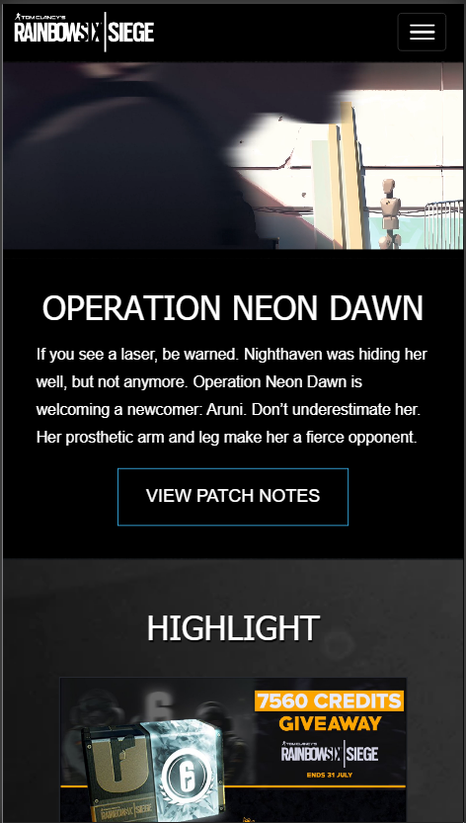

**Example 2:**

***Is the site Cross Browser Compatible?***

Yes, the site is Cross Browser Compatible. All the buttons are operating properly in different websites. The sites are responsive in all the browser tested.

**Chrome:**

**Firefox:**

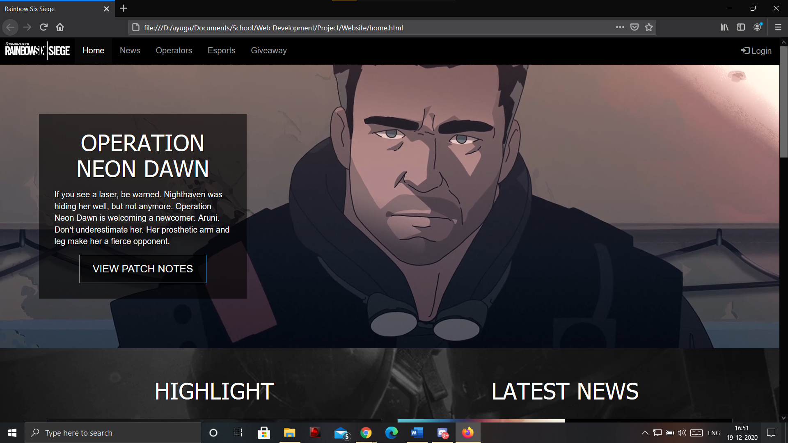

**Microsoft Edge:**

# Site Evaluation

***You must describe how you evaluated your website using appropriate heuristics.***

1. Visibility of system status

* Appropriate messages are provided for the user to know what is going on.
* e.g., If the form is not filled completely, the border around the missing input fields turn red and a message below saying “Please fill ….” is displayed.
* The navigation bar shows exactly on which page the user is by highlighting the said page tab.

1. Match between system and the real world

* Information is presented in a clear and logical manner.
* No technical terms are used which the users will not be familiar with.

1. User control and freedom

* Links are provided in the navigation page for the user to go back to the homepage or any other page at any given time.

1. Consistency and standards

* The layout and design of the website look similar on every page.
* The same navigation bar is used and is always at the top of the page.
* The same social media bar is use and is always at the bottom of the content section along with the footer.

1. Flexibility and efficiency of use

* The site is designed for both experienced and inexperienced users.
* This was tested using people (family) who had no knowledge of the website.

1. Aesthetic and minimalist design

* The content displayed is kept to a minimum.
* Extra information is supplied only when the user wishes to know more and clicks the button below such section labelled as “Read More”.
* Instead of displaying information about each character one by one, its is compacted into displaying only 1-character description which changes to another character description when the button for the said character is clicked.

1. Help and documentation

* Comments are provided throughout the CSS and JavaScript to make it easy to maintain the website.
* Every section is given a proper Id to identify the what content it represents.

# Deployment

***Describe how the website was made available online.***

To deploy the website, follow the steps below:

1. Acquire hosting
2. Get a Domain name
3. Set site meta tags and register site with Google Search Engine
4. Upload content website to root folder of the host using FTP
5. Add Link to google

***Describe the techniques used for Search Engine Optimisation (SEO)***

Meta Tags are used to describe the contents of the website. The search engines will use this description to match with what the users enter in search engines. Proper descriptions will allow our website to be more discoverable and make it easy for people to find if they are looking for information on Rainbow Six Siege.

Description would be: The site is useful for gaining information about Rainbow Six Siege and its Esports News.

Keywords would be: Rainbow6, Esports, Operators, Siege.

# Appendices

***Weekly Logs***

Week 1

I am thinking of making the project on a store page for gaming or maybe a store page for an Esports organisation. I checked out many store pages of different Esports teams like G2, NAVI, TSM etc. This gives a basic idea of how my page should be laid out.

I will research more about this and will hopefully make a full start by the end of this week.

Week 2

I made a basic HTML page with a bit of CSS. It is like a framework with placeholder text and images. It is still a prototype as I do not know JavaScript as much yet, so I don’t know where that will fit in.

The basic page includes a navigation bar, the header (coloured bar) and a table to contain information and images.

Week 3

Not made much progress this week on the website itself. Just learnt different ways to use JavaScript in my website. Made a list of things to be added in my website like adding buttons. Finally selected to make the website on my favourite game “Rainbow Six Siege”.

Also clicked some pictures to be used on the website. I have made a structure to the website:

1. Index Page (showing all the categories: News, Operators, etc.)
2. Each Category has its own page.

Week 4

Finish the Home page for the project. Added Carousel and buttons using JavaScript. The page is built using Bootstrap. I will add this Bootstrap to all the pages. This will make all the page look the same and provide continuity.

Forms will be added in the last page, where user will have to enter their details for delivery. Wireframes are done, but the description and everything else is still remaining.

Week 5

Shifted the Carousel to the Esports page. For the Home Page, I added a video as a background with the content displayed in a semi-transparent box. Finished all the pages of the website. The JavaScript is completed and is working perfectly. Making the site responsive is the only thing remaining. It will be done by the end of this week and will be ready to submit.